Week 8 - Graded Mini Project
Learning Outcome Addressed
- Data Extraction and Manipulation Using SQL and Pandas
- Deriving Business Insights through Exploratory Data Analysis and Visualisation

Objective
This mini project is designed to help you explore and analyse retail sales data using SQL, Pandas, and Python visualisations. You’ll work with two datasets: one containing stock information and another recording sales transactions. Through a combination of structured queries and Python-based EDA, you'll derive business insights such as bestselling items, customer purchasing patterns, and revenue trends.
Submission Instructions
Please document your response on the following pages.
Once you have completed the activity, save the file as a PDF and upload it. Be sure to name the file as Module 8: Graded Mini Project_[Your last name].
Your submission will be considered complete when it meets the following criteria:
- Includes all the key elements outlined in the activity instructions and the rubric.
- Add screenshots of visual outputs wherever required.
- Adheres to the submission guidelines.
- Is submitted on time.
This is a required activity and counts towards programme completion.
Reflect on the task and respond to the following questions.

A. Basic SQL Queries (5 Tasks)- Load csv files in database. (Note: Kindly provide the solution in the form of an SQL query.)
Question: Retrieve all stock items that contain the word "T-LIGHT" in their description.
select * from sales_transactions where description like '%T-LIGHT%'

Question: Calculate the total quantity sold per StockCode.
select stockcode,sum(quantity) from sales_transactions group by stockcode

Question: Find total revenue (Quantity × UnitPrice) per CustomerID.
select customerid,sum(unitprice * quantity) from sales_transactions
group by customerid

Question: Get a list of all invoices and count of distinct stock items per invoice.
select invoiceno,count(distinct description) count_of_stock_items from sales_transactions
group by invoiceno

Question: Perform an inner join between sales and stock details to display full item names along with total revenue per item.
SELECT
p.StockCode,
p.Description AS ItemName,
SUM(s.Quantity * s.UnitPrice) AS TotalRevenue
FROM sales_transactions s
INNER JOIN stocks p
ON s.StockCode = p.StockCode
GROUP BY
p.StockCode,
p.Description
ORDER BY
TotalRevenue DESC;

B. EDA Using Pandas (5 Tasks) (Note: Kindly provide the lines of python code.)
Question: Check for missing values, data types, and duplicates in both datasets.
import pandas as pd

sales_path = base / 'sales.csv'
stock_path = base / 'StockDetails.csv'

print('Sales dataset missing values')
sales = pd.read_csv(sales_path)
print(sales.info())

print('StockDetails dataset missing values')
stockdetails = pd.read_csv(stock_path)
print(stockdetails.info())

print('Duplicates in sales dataset')
print(sales[sales.duplicated()])

print('Duplicates in stocks dataset')
print(stockdetails[stockdetails.duplicated()])

Question: Convert InvoiceDate into datetime, and extract:
- Invoice date
- Month
- Hour of transaction
import pandas as pd

sales_path = 'sales.csv'
stock_path = 'StockDetails.csv'

sales_df = pd.read_csv(sales_path)
stock_df = pd.read_csv(stock_path)

# Convert InvoiceDate to datetime and extract Invoice date, Month, Hour
sales_df['InvoiceDate'] = pd.to_datetime(sales_df['InvoiceDate'], errors='coerce')
# Invoice date (date only)
sales_df['Invoice_date'] = sales_df['InvoiceDate'].dt.date
# Month number (1-12)
sales_df['Month'] = sales_df['InvoiceDate'].dt.month
# Hour of transaction (0-23)
sales_df['Hour'] = sales_df['InvoiceDate'].dt.hour
print('Converted InvoiceDate — NaT values:', sales_df['InvoiceDate'].isna().sum())
# Show sample of new columns
sales_df[['InvoiceDate', 'Invoice_date', 'Month', 'Hour']].head()

Question: Add a new column TotalPrice = Quantity × UnitPrice.
import pandas as pd

sales_path = 'sales.csv'
stock_path = 'StockDetails.csv'

sales_df = pd.read_csv(sales_path)
stock_df = pd.read_csv(stock_path)

sales_df['TotalPrice']=sales_df['Quantity']*sales_df['UnitPrice']
sales_df

Question: Identify the top 3 bestselling items by quantity sold.
# Top 3 bestselling items by quantity sold (only positive Quantity = actual sales)
sold_qty = (sales_df[sales_df['Quantity'] > 0]
.groupby(['StockCode', 'Description'], dropna=False)['Quantity']
.sum()
.reset_index(name='SoldQty')
.sort_values('SoldQty', ascending=False))

print('Top 3 items by Sold Quantity (positive quantities only):')
display(sold_qty.head(3))

Question: Find out how many unique customers made purchases and the average quantity per invoice.
# ...existing code...
# Unique customers who made purchases and average quantity per invoice
n_unique_customers = sales_df.loc[sales_df['Quantity'] > 0, 'CustomerID'].dropna().nunique()
invoice_qty = sales_df.groupby('InvoiceNo')['Quantity'].sum()
positive_invoices = invoice_qty[invoice_qty > 0]
avg_qty_per_invoice = positive_invoices.mean()

print('Unique customers who made purchases:', n_unique_customers)
print(f'Average quantity per (positive) invoice: {avg_qty_per_invoice:.2f} (n_invoices={len(positive_invoices)})')

C. Visualisation (5 Tasks) (Note: Kindly provide the lines of python code and the screenshots of charts and plots.)
Question: Plot a bar chart of top 10 items by quantity sold.
import matplotlib.pyplot as plt
import seaborn as sns
sold_qty = (sales_df[sales_df['Quantity'] > 0]
.groupby(['StockCode', 'Description'], dropna=False)['Quantity']
.sum()
.reset_index(name='SoldQty')
.sort_values('SoldQty', ascending=False))
top10 = sold_qty.head(10)
plt.figure(figsize=(10,6))
sns.barplot(data=top10, x='SoldQty', y='Description')
plt.xlabel('Total Quantity Sold')
plt.ylabel('Item Description')
plt.title('Top 10 Items by Quantity Sold')
plt.tight_layout()
plt.show()
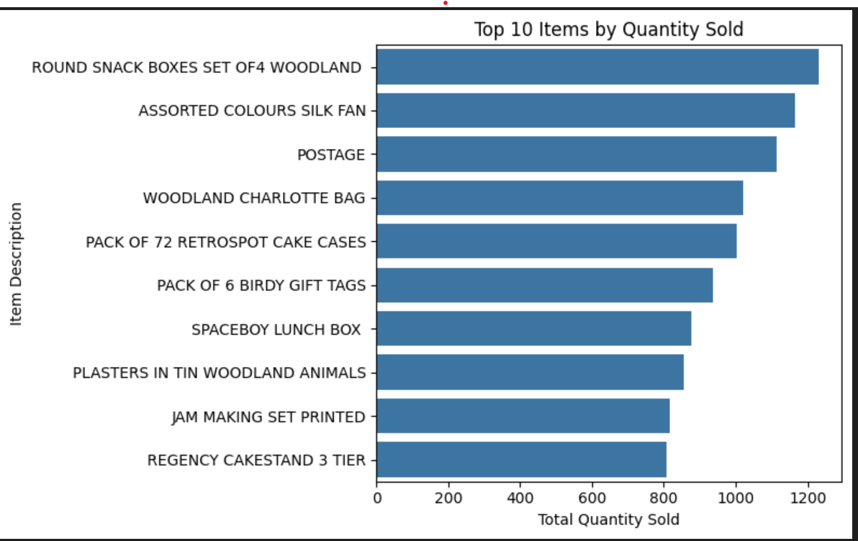

Question: Plot total sales per hour of the day to understand peak shopping hours.
import matplotlib.pyplot as plt
import seaborn as sns

if 'TotalPrice' not in sales_df.columns:
sales_df['TotalPrice'] = sales_df['Quantity'] * sales_df['UnitPrice']
if 'Hour' not in sales_df.columns:
sales_df['InvoiceDate'] = pd.to_datetime(sales_df['InvoiceDate'], errors='coerce')
sales_df['Hour'] = sales_df['InvoiceDate'].dt.hour

hourly = (sales_df.groupby('Hour', dropna=False)
.agg(TotalSales=('TotalPrice', 'sum'),
Transactions=('InvoiceNo', 'nunique'))
.reset_index()
.sort_values('Hour'))

plt.figure(figsize=(10,5))
sns.barplot(data=hourly, x='Hour', y='TotalSales', color='steelblue')
plt.xlabel('Hour of Day')
plt.ylabel('Total Sales')
plt.title('Total Sales by Hour of Day')
plt.xticks(range(0,24))
plt.tight_layout()
plt.show()

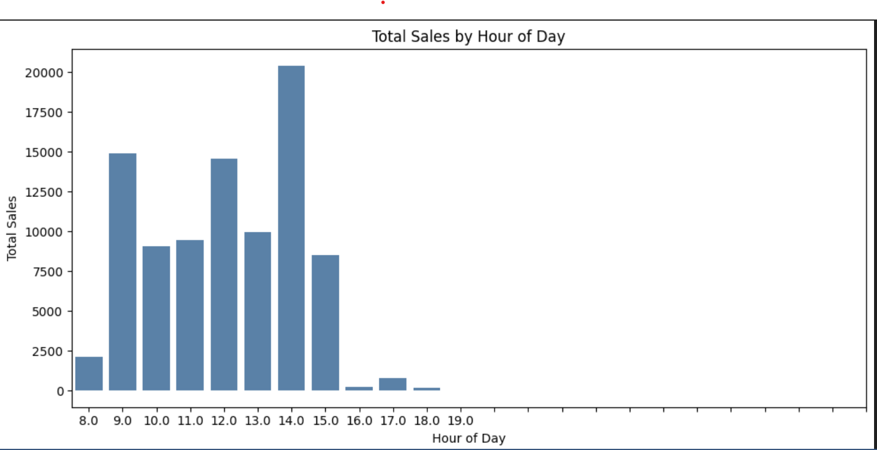

Question: Create a pie chart showing revenue distribution among top 5 customers.
import matplotlib.pyplot as plt
import pandas as pd

# Ensure TotalPrice exists
if 'TotalPrice' not in sales_df.columns:
sales_df['TotalPrice'] = sales_df['Quantity'] * sales_df['UnitPrice']

# Revenue by customer (exclude missing CustomerID)
revenue_by_customer = (sales_df.dropna(subset=['CustomerID'])
.groupby('CustomerID')['TotalPrice']
.sum()
.sort_values(ascending=False))

top5 = revenue_by_customer.head(5)
others = revenue_by_customer.iloc[5:].sum()
pie_data = pd.concat([top5, pd.Series({'Other': others})])

plt.figure(figsize=(7,7))
plt.pie(pie_data, labels=pie_data.index.astype(str), autopct='%1.1f%%', startangle=140)
plt.title('Revenue distribution: Top 5 customers vs Others')
plt.tight_layout()
plt.show()
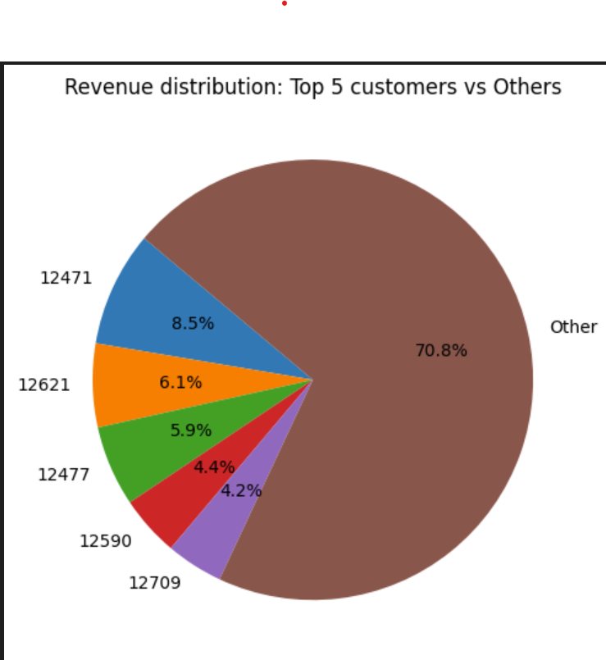

Question: Visualise the monthly revenue trend using a line chart.
import matplotlib.pyplot as plt
import seaborn as sns

# ensure InvoiceDate and TotalPrice exist
sales_df['InvoiceDate'] = pd.to_datetime(sales_df['InvoiceDate'], errors='coerce')
if 'TotalPrice' not in sales_df.columns:
sales_df['TotalPrice'] = sales_df['Quantity'] * sales_df['UnitPrice']

sales_df = sales_df.dropna(subset=['InvoiceDate'])
sales_df['YearMonth'] = sales_df['InvoiceDate'].dt.to_period('M').astype(str)

monthly = (sales_df.groupby('YearMonth')
.agg(TotalRevenue=('TotalPrice', 'sum'),
Transactions=('InvoiceNo', 'nunique'))
.reset_index())

monthly['YearMonth_dt'] = pd.to_datetime(monthly['YearMonth'])

plt.figure(figsize=(10,5))
sns.lineplot(data=monthly.sort_values('YearMonth_dt'), x='YearMonth_dt', y='TotalRevenue', marker='o')
plt.xlabel('Month')
plt.ylabel('Total Revenue')
plt.title('Monthly Revenue Trend')
plt.xticks(rotation=45)
plt.tight_layout()
plt.show()
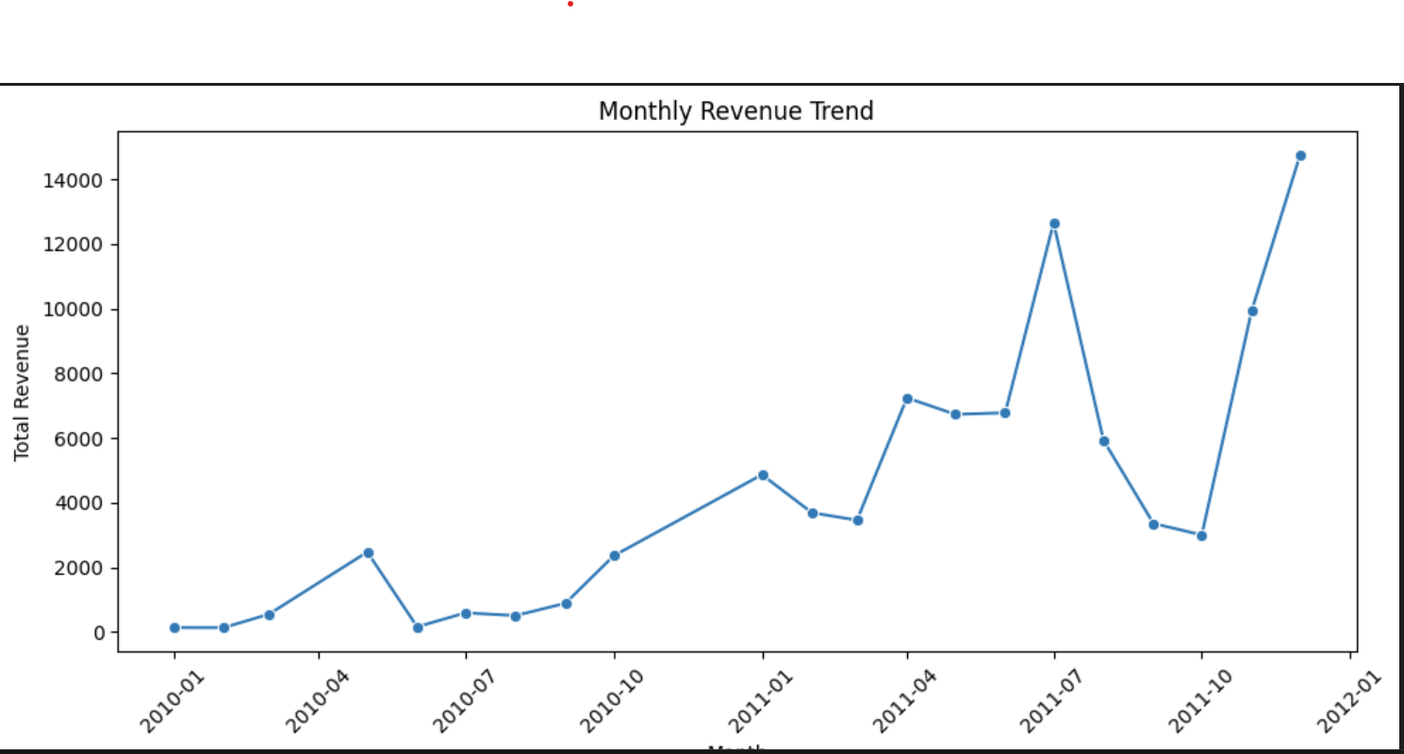

Question: Create a stacked bar chart of top 5 invoices by revenue, showing contribution from each item.
import matplotlib.pyplot as plt

# Ensure TotalPrice exists
if 'TotalPrice' not in sales_df.columns:
sales_df['TotalPrice'] = sales_df['Quantity'] * sales_df['UnitPrice']

# Use only positive revenue lines and treat InvoiceNo as string
sales_pos = sales_df[sales_df['TotalPrice'] > 0].copy()
sales_pos['InvoiceNo'] = sales_pos['InvoiceNo'].astype(str)

# Top 5 invoices by total revenue
top_invoices = (sales_pos.groupby('InvoiceNo')['TotalPrice'].sum()
.nlargest(5).index.tolist())

# Pivot to get revenue contribution per item for each top invoice
invoice_item = (sales_pos[sales_pos['InvoiceNo'].isin(top_invoices)]
.groupby(['InvoiceNo', 'Description'])['TotalPrice'].sum()
.reset_index()
.pivot(index='InvoiceNo', columns='Description', values='TotalPrice')
.fillna(0))

# Sort item columns by total contribution for consistent stacking
invoice_item = invoice_item[invoice_item.sum().sort_values(ascending=False).index]

# Plot stacked bar chart
plt.figure(figsize=(10,6))
invoice_item.plot(kind='bar', stacked=True, width=0.7, ax=plt.gca())
plt.ylabel('Revenue')
plt.title('Top 5 Invoices by Revenue — Item contribution')
plt.legend(bbox_to_anchor=(1.02, 1), loc='upper left')
plt.tight_layout()
plt.show()
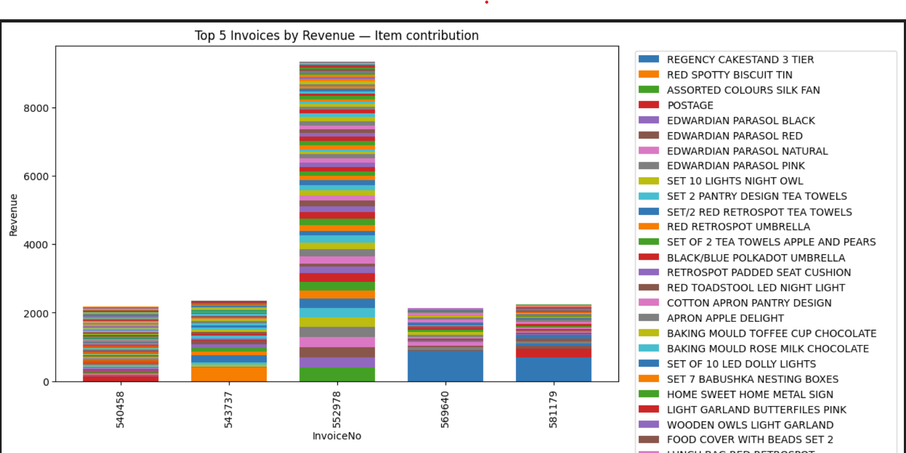

D. Business Insights (5 Tasks) (Note: Kindly provide the lines of python code.)
Question: Identify which product generates the highest total revenue.
# Identify product with highest total revenue
if 'TotalPrice' not in sales_df.columns:
sales_df['TotalPrice'] = sales_df['Quantity'] * sales_df['UnitPrice']

product_rev = (sales_df.groupby(['StockCode', 'Description'], dropna=False)['TotalPrice']
.sum()
.reset_index(name='TotalRevenue')
.sort_values('TotalRevenue', ascending=False))

top_product = product_rev.iloc[0]
display(product_rev.head(5))

Question: Determine average order value per invoice.
invoice_totals = sales_df.groupby('InvoiceNo', dropna=False)['TotalPrice'].sum()
pos_invoice_totals = invoice_totals[invoice_totals > 0]

avg_order_value = pos_invoice_totals.mean()
median_order_value = pos_invoice_totals.median()
n_invoices = len(pos_invoice_totals)

print(f'Average order value (per positive invoice): {avg_order_value:.2f} (n_invoices={n_invoices})')
print(f'Median order value: {median_order_value:.2f}')

Question: Find the customer with the highest number of transactions.
sales_df['InvoiceNo'] = sales_df['InvoiceNo'].astype(str)
transactions = (sales_df[sales_df['TotalPrice'] > 0]
.dropna(subset=['CustomerID'])
.drop_duplicates(subset=['CustomerID', 'InvoiceNo'])
.groupby('CustomerID')['InvoiceNo']
.nunique()
.sort_values(ascending=False))

if len(transactions) == 0:
print('No valid transactions found.')
else:
top_customer = transactions.index[0]
top_count = transactions.iloc[0]
print(f'Customer with most transactions: {top_customer} (n_transactions={top_count})')
display(transactions.head(10))

Question: Check how many products in the sales data do not have a matching entry in the stockDetails file.
if 'stock_df' not in globals():
try:
stock_df = pd.read_csv('StockDetails.csv')
except Exception:
stock_df = None

sales_codes = sales_df['StockCode'].astype(str).str.strip().dropna().unique()
if stock_df is None or 'StockCode' not in stock_df.columns:
print('StockDetails not loaded or missing StockCode column.')
else:
stock_codes = stock_df['StockCode'].astype(str).str.strip().dropna().unique()
missing = sorted(set(sales_codes) - set(stock_codes))
print(f'Products in sales missing from StockDetails: {len(missing)}')
print('Sample missing StockCodes:', missing[:20])

